**UNIVERSITY OF BUEA REPUBLIC OF CAMEROON**

P.O Box 63, PEACE-WORKFATHERLAND  
Buea South West Region   
CAMEROON   
Tel: (237) 3332 21 34/3332 26 90   
Fax: (237) 3332 2272



FACULTY OF ENGINEERING AND TECHNOLOGYDEPARTMENT OF COMPUTER ENGINEERING

OPERATIONAL RESEARCH (CEF 401)

**LINEAR PRGRAMMING PROBLEM: Simplex Method and Sensitivity Analysis**

**GROUP 6**

|  |  |
| --- | --- |
| **KAMCHE YANN ARNAUD** | **FE21A208** |
| **KAH JOSPEN NGUM** | **FE21A207** |
| **INDAH RISCOBELLE MBAH** | **FE21A204** |
| **JENNA EBOT AGBOR** | **FE21A205** |
| **IHIMBRU ZADOLF ONGUM** | **FE21A203** |
| **FOWEDLUNG ATSAFAC AGAFINA** | **FE21A196** |
| **FOTABONG FUALEFAC PUISSANCE** | **FE21A195** |
| **FOZAO JARID NZOLEFACK** | **FE20A042** |
| **FONJI DANIEL KUKUH,** | **FE21A194** |
| **GEORGE NKENG TABI NTANGSI** | **FE19A044** |

Option: Software Engineering  
Academic SupervisorDr. SIMO  
Dr. AZEUFACK  
University of Buea  
Academic Year: 2023/24

**TABLE OF CONTENTS**

1. General Introduction…………………………………………….
2. Definition of Linear Programming………………………………
3. The Simplex Method……………………………………………
   1. Algorithm………………………………………………….
   2. Problem…………………………………………………….
   3. Solution……………………………………………………
   4. Step 1: Set up the problem………………………………….
   5. Step 2: Convert the inequalities into equations……………
   6. Step 3: Construct the initial simplex tableau………………
   7. Step 4: Identify the pivot column………………………….
   8. Step 5: Calculate the quotients……………………………..
   9. Step 6: Perform pivoting…………………………………..
   10. Step 7: Check for negative entries…………………………
   11. Step 8: Read off your answers……………………………..
4. Conclusion……………………………………………………….

1. **GENERAL INTRODUCTION**

Linear Programming (LP) is a mathematical optimization technique with a rich historical background and wide-ranging applications. It has evolved as an essential tool for rational decision-making and resource allocation, shaping various fields. The historical significance of LP can be traced back to the mid-20th century when eminent figures like George Dantzig, Leonid Kantorovich, and Tjalling Koopmans made seminal contributions, laying the foundation for LP as a pivotal mathematical optimization method. In today’s context:

1. **Engineering and Operations Research:** It optimizes resource allocation in engineering projects, scheduling, and supply chain operations.
2. **Agriculture:** LP enhances resource management in agriculture, improving land and crop utilization.
3. **Public Policy:** Governments use LP for efficient resource allocation in healthcare, education, and infrastructure.
4. **Environmental Impact:** LP contributes to environmentally responsible practices in waste management and energy allocation.

This project emphasizes the increasing significance of LP and the graphical method as fundamental skills for addressing resource allocation challenges across domains. Proficiency in these techniques equips individuals to make informed decisions and contribute to efficiency and sustainability.

**2. Definition of Linear Programming:**Linear programming is a mathematical method used to optimize operations while adhering to certain constraints. Its primary goal is to maximize or minimize a numerical value. Linear programming problems involve linear functions subject to constraints in the form of linear equations or inequalities. The term "linear programming" comprises two words: "linear," indicating the relationship between variables with a degree of one, and "programming," defining the process of selecting the best solution from various alternatives.**3. SIMPLEX METHOD**

**3.1 Algorithm**

1. **Set up the problem.** That is, write the objective function and the inequality constraints.
2. **Convert the inequalities into equations.** This is done by adding one slack variable for each inequality.
3. **Construct the initial simplex tableau.** Write the objective function as the bottom row.
4. **The most negative entry in the bottom row identifies the pivot column.**
5. **Calculate the quotients. The smallest quotient identifies a row. The element in the intersection of the column identified in step 4 and the row identified in this step is identified as the pivot element.** The quotients are computed by dividing the far right column by the identified column in step 4. A quotient that is a zero, or a negative number, or that has a zero in the denominator, is ignored.
6. **Perform pivoting to make all other entries in this column zero.** This is done the same way as we did with the Gauss-Jordan method.
7. **When there are no more negative entries in the bottom row, we are finished; otherwise, we start again from step 4.**
8. **Read off your answers.** Get the variables using the columns with 1 and 0s. All other variables are zero. The maximum value you are looking for appears in the bottom right-hand corner.

**3.2 Problem**

Mike holds two part-time jobs, Job1 and Job2. He never wants to work more than 12 hours a week. He has determined that for every hour he works at Job1, he needs 2 hours of preparation time, and for every hour he works at Job2, he needs one hour of preparation time, and he cannot spend more than 16 hours on preparation. If he makes $40 an hour at Job1, and $30 an hour at Job2, how many hours should he work per week at each job to maximize his income?

**3.3 Solution**

In solving this problem, we will follow the algorithm listed above.

***3.4 STEP 1*.** **Set up the problem. Write the objective function and the constraints.**

Let **x1** = The number of hours per week MIke will work at Job1 and

**X2** = The number of hours per week Niki will work at Job2.

It is customary to choose the variable that is to be maximized as Z

Maximize $Z = 40x1+30x2$

Subject to: $x1+x2 ≤ 12$

$2x1+x2 ≤ 16$

$x1, x2 ≥ 0$

***3.5 STEP 2***. **Convert the inequalities into equations. This is done by adding one slack variable for each inequality.**

For example to convert the inequality $x1+x2 ≤ 12$

into an equation, we add a non-negative variable $y1$, and we get $x1+x2+y1 = 12$

Here the variable, y1 picks up the slack, and it represents the amount by which $x1+x2$ falls short of 12. In this problem, if Mike works fewer than 12 hours, say 10, then $y1$ is 2. Later when we read off the final solution from the simplex table, the values of the slack variables will identify the unused amounts.

We rewrite the objective function $Z = 40x1+30x2$ as $-40x1-30x2+ Z= 0$

.

After adding the slack variables, our problem reads

Objective function $-40x1-30x2+ Z= 0$

Subject to constraints: $x1+x2+y1 = 12$

$2x1+x2+y2 = 16$

$x1, x2 ≥ 0$

***3.6 STEP 3***. **Construct the initial simplex tableau. Each inequality constraint appears in its own row. (The non-negativity constraints do not appear as rows in the simplex tableau.) Write the objective function as the bottom row.**

Now that the inequalities are converted into equations, we can represent the problem into an augmented matrix called the initial simplex tableau as follows.

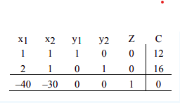

Here the vertical line separates the left-hand side of the equations from the right side. The horizontal line separates the constraints from the objective function. The right side of the equation is represented by the column C.

If we arbitrarily choose x1=0 and x2=0, we get

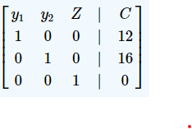

which reads $y1=12, y2=16, Z=0$

The solution obtained by arbitrarily assigning values to some variables and then solving for the remaining variables is called the **basic solution** associated with the tableau. So the above solution is the basic solution associated with the initial simplex tableau. We can label the basic solution variable in the right of the last column as shown in the table below.

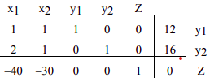

***3.7 STEP 4***. **The most negative entry in the bottom row identifies the pivot column.**

The most negative entry in the bottom row is -40; therefore column 1 is identified.

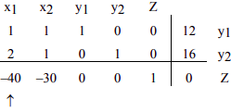

**Question** Why do we choose the most negative entry in the bottom row?

**Answer** The most negative entry in the bottom row represents the largest coefficient in the objective function - the coefficient whose entry will increase the value of the objective function the quickest.

The simplex method begins at a corner point where all the main variables, the variables that have symbols such as x1, x2, x3, etc., are zero. It then moves from a corner point to the adjacent corner point always increasing the value of the objective function. In the case of the objective function $Z = 40x1+30x2$, it will make more sense to increase the value of x1 rather than x2. The variable x1 represents the number of hours per week Niki works at Job I. Since Job I pays $40 per hour as opposed to Job II which pays only $30, the variable x1 will increase the objective function by $40 for a unit of increase in the variable x1

***3.8 STEP 5***. **Calculate the quotients. The smallest quotient identifies a row. The element in the intersection of the column identified in step 4 and the row identified in this step is identified as the pivot element.**

Following the algorithm, in order to calculate the quotient, we divide the entries in the far right column by the entries in column 1, excluding the entry in the bottom row.

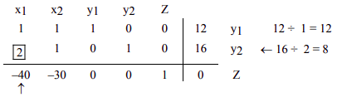

The smallest of the two quotients, 12 and 8, is 8. Therefore row 2 is identified. The intersection of column 1 and row 2 is the entry 2, which has been highlighted. This is our pivot element.

**Question** Why do we find quotients, and why does the smallest quotient identify a row?

**Answer** When we choose the most negative entry in the bottom row, we are trying to increase the value of the objective function by bringing in the variable x1. But we cannot choose any value for x1. Can we let x1=100? Definitely not! That is because Mike never wants to work for more than 12 hours at both jobs combined: $x1+x2 ≤ 12$. Can we let x1=12? Again, the answer is no because the preparation time for Job1 is two times the time spent on the job. Since Mike never wants to spend more than 16 hours on preparation, the maximum time he can work is 16 ÷ 2 = 8.

Now you see the purpose of computing the quotients; using the quotients to identify the pivot element guarantees that we do not violate the constraints.

**Question** Why do we identify the pivot element?

**Answer** As we have mentioned earlier, the simplex method begins with a corner point and then moves to the next corner point always improving the value of the objective function. The value of the objective function is improved by changing the number of units of the variables. We may add the number of units of one variable (**entering variable**) while throwing away the units of another (**departing variable**). Pivoting allows us to do just that.

The entering variable in the above table is x1, and it was identified by the most negative entry in the bottom row. The departing variable y2 was identified by the lowest of all quotients.

**3.9 STEP 6**. Perform pivoting to make all other entries in this column zero.

So now our job is to make our pivot element a 1 by dividing the entire second row by 2. The result follows.

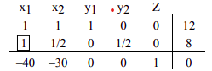

To obtain a zero in the entry first above the pivot element, we multiply the second row by -1 and add it to row 1. We get

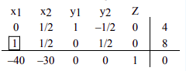

To obtain a zero in the element below the pivot, we multiply the second row by 40 and add it to the last row.

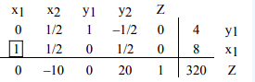

We now determine the basic solution associated with this tableau. By arbitrarily choosing x2=0 and y2=0, we obtain x1=8, y1=4, and z=320. If we write the augmented matrix, whose left side is a matrix with columns that have one 1 and all other entries zeros, we get the following matrix stating the same thing.

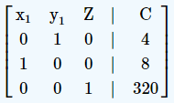

We can restate the solution associated with this matrix as x1=8, x2=0, y1=4, y2=0 and z=320.

At this stage of the game, it reads that if Mike works 8 hours at Job I, and no hours at Job II, her profit Z will be $320. Recall from Example 3.1.1 in section 3.1 that (8, 0) was one of our corner points. Here y1=4 and y2=0 mean that he will be left with 4 hours of working time and no preparation time.

***3.10 STEP 7***. **When there are no more negative entries in the bottom row, we are finished; otherwise, we start again from step 4.**

Since there is still a negative entry, -10, in the bottom row, we need to begin, again, from step 4. This time we will not repeat the details of every step, instead, we will identify the column and row that give us the pivot element, and highlight the pivot element. The result is as follows.

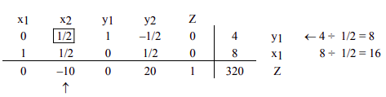

We make the pivot element 1 by multiplying row 1 by 2, and we get

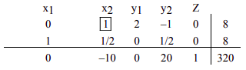

Now to make all other entries as zeros in this column, we first multiply row 1 by -1/2 and add it to row 2, and then multiply row 1 by 10 and add it to the bottom row.

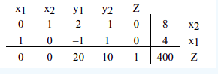

We no longer have negative entries in the bottom row, therefore we are finished.

**Question** Why are we finished when there are no negative entries in the bottom row?

**Answer** The answer lies in the bottom row. The bottom row corresponds to the equation:

$0x1+0x2+20y1+10y2+Z=400$ or $Z=400-20y1-10y2$

Since all variables are non-negative, the highest value Z

can ever achieve is 400, and that will happen only when y1

and y2

are zero.

**3.11 STEP 8. Read off your answers.**

We now read off our answers, that is, we determine the basic solution associated with the final simplex tableau. Again, we look at the columns that have a 1 and all other entries zeros. Since the columns labeled y1

and y2 are not such columns, we arbitrarily choose y1=0, and y2=0, and we get

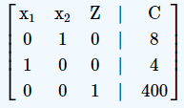

The matrix reads x1=4, x2=8

and z=400

The final solution says that if Mike works 4 hours at Job1 and 8 hours at Job2, he will maximize his income to $400. Since both slack variables are zero, it means that he would have used up all the working time, as well as the preparation time, and none will be left.

1. **CONCLUSION**

In conclusion, the simplex method and sensitivity analysis are powerful tools for addressing linear programming problems with practical applications in various domains. The simplex method provides an efficient way to find the optimal solution to resource allocation and profit maximization problems, while sensitivity analysis allows decision-makers to assess the impact of changes in parameters such as profit margins and resource availability. These techniques play a vital role in helping businesses and organizations make informed decisions that maximize profits and optimize resource utilization. As industries continue to evolve, the application of linear programming, the simplex method, and sensitivity analysis remains crucial in adapting to changing circumstances and achieving efficiency and sustainability.

In a world where efficiency and optimal resource utilization are paramount, linear programming remains a cornerstone of mathematical problem solving and continues to shape our approach to tackling complex, real-world challenges. It stands as a testament to the power of mathematics in aiding decision-making and finding the best solutions in diverse fields and industries.